Project Name: MCU-Only Signal Acquisition & Processing
Platform: STM32 Nucleo-F446RE
Author: Miguel Leon
Date: 12/22/2025
Tools: STM32CubeIDE, C, ADC, DMA, Timers

Project Overview
The system captures real-world analog signals using the STM32 ADC at a controlled sampling rate defined by hardware timers. The sampled data is processed directly on the microcontroller, demonstrating real-time embedded signal acquisition under memory and timing constraints.
System Architecture
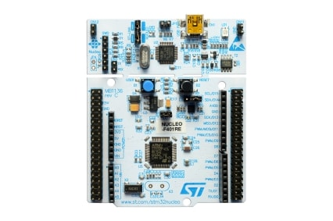
The system is implemented on an STM32 Nucleo-F446RE development board based on an ARM Cortex-M4 microcontroller. This platform provides a 12-bit ADC with hardware trigger support, multiple high-resolution timers for deterministic sampling, and sufficient on-chip memory for buffered signal processing. The Cortex-M4 core includes DSP instructions and floating-point support, enabling real-time signal processing under embedded constraints. Integrated debugging support allows direct observation and validation of system behavior during development.

Key Design Decisions
I chose STM32 over an Arduino for better ADC and DMA support.
Implementation Details
Phase 0 – Toolchain + Basic Peripheral Verification
- GPIO
- Timer
- Proves:
  - STMicroelectronics toolchain works
  - The STM32F446RE is alive
  - Interrupts and clocks are functioning
Phase 1 - Signal acquisition via potentiometer connection
Date: Dec 24, 2025 – Dec 26 ,2025
Goal: Read analog input using STM32 ADC
Hardware:
- STM32 Nucleo board
- 2-axis potentiometer joystick
Description: The STM32 board supplies fixed voltages. The board contains 12-bit ADC peripherals that sample the continuous voltage generated at an input pin and converts it into one of 4096 discrete digital values based on a 3.3 V reference voltage. This process converts an analog physical quantity into a digital representation that firmware can process.
What I did:
- Wired potentiometer as voltage divider between 3.3V and GND
- Configured ADC to sample channel X
- Read ADC value in main loop
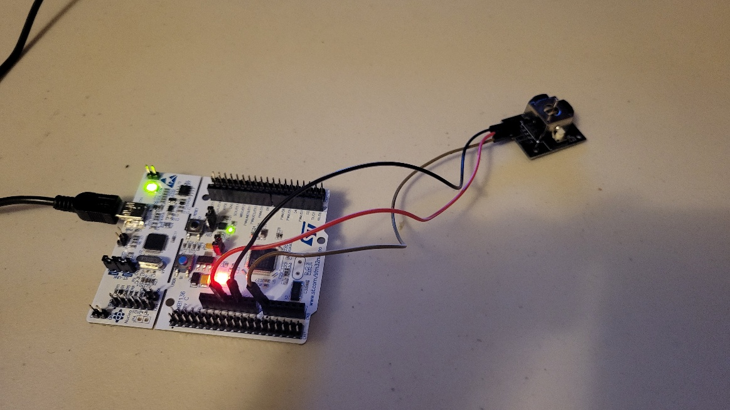
- STM32 Nucleo board connected to the 2-axis potentiometer joystick
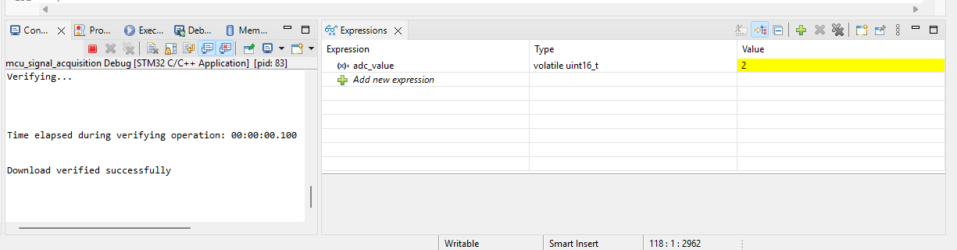
- Potentiometer knob turned left.
- Close to 0, or 0.0 V
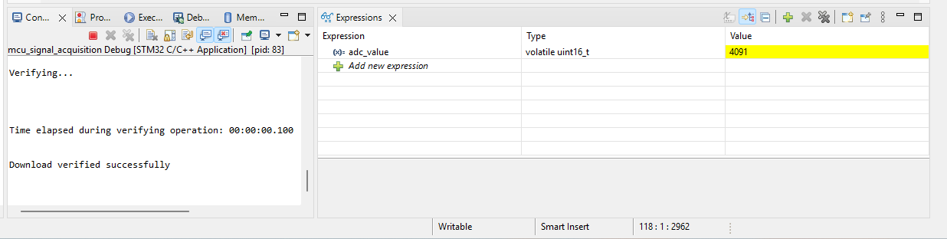
- Potentiometer knob turned right.
- Close to 4095. The max value is 4095 because the ADC is 12-bit.
What I learned:
The STM32 Nucleo board provides regulated supply voltages, including a 3.3 V rail used as the ADC reference. A potentiometer was used as a variable voltage divider, producing an analog voltage proportional to the wiper position.
The ADC samples this analog voltage and converts it into a digital value based on its resolution. The STM32 ADC operates at 12-bit resolution, providing $2^{12}=4096$ discrete quantization levels with output codes ranging from 0 to 4095. These codes represent input voltages from approximately 0 V up to the ADC reference voltage. This process illustrates voltage quantization, where a continuous analog signal is mapped into discrete digital levels for processing by the microcontroller.
Issues / questions:
- Unsure how sampling time affects noise
- Not clear when DMA is needed

Phase 2 – Signal actuation via PWM
Date: Dec 26, 2025 – Dec 27, 2025
Goal: In this phase, hardware-based signal actuation was implemented using the STM32 timer peripheral configured for Pulse Width Modulation (PWM). A general-purpose timer (TIM3) was set to generate a PWM waveform on a GPIO pin, allowing digital duty-cycle values to control the average output power delivered to an external LED. The PWM signal was generated autonomously by the timer hardware, while the CPU updated the duty cycle in software. Changes in duty cycle resulted in smooth, continuous LED brightness variation, validating correct timer configuration, pin multiplexing, and real-time actuation behavior.
Hardware:
- 220 Ohm resistor
- Red LED
- STM32 Nucleo board
What I Did: I setup a simple circuit consisting of a 220 ohm resistor connected to a red LED
Video Demo: https://youtu.be/P8PqJ9iEa18
Problems Encountered & Debugging: Initial output issues were caused by incorrect timer-to-pin alternate function mapping and insufficient forward voltage headroom when driving a white LED directly from a 3.3 V GPIO.
One pin that I tried to use to get the PWM signal was dead or inactive. I thought I had correctly configured the pin using CubeMX but the pin was not working. I had to move to another pin.
Another issue I had was at first, I tried to light up a white LED, but it would not light up. Different LEDs need different minimum voltages before they conduct.
LED color | Typical Vf
Red | ~1.8–2.0 V
Green | ~2.0–2.2 V
Blue | ~3.0–3.3 V
White | ~3.0–3.4 V

The STM32 GPIOs have a max output of 3.3 V, often slightly less under load. White LEDs are actually blue LEDs + phosphor. When
- GPIO ≈ 3.3 V
- LED Vf ≈ 3.2–3.4 V
- Resistor drops some voltage
- GPIO current is limited (~20 mA max)
There is not enough voltage headroom which resulted in the LED not glowing at all.
The red LED worked immediately because red LEDs need much lower forward voltages, need less voltage headroom, and need less current stress on GPIOs. This makes them ideal for MCU demos.

What I learned: Timers are essential peripherals within a microcontroller. Timers allow microcontrollers to perform precise functions such as communicate over UART, SPI, I2C, blink LEDs accurately, sample ADC at fixed intervals, and much more. The function of times that mattered for this phase is PWM. PWM is generated using hardware timers and are one of the primary techniques used by digital systems to control analog-like behavior in physical devices. PWM consists of square waves which are either high (max voltage, or on) or low (0 voltage, off).
In this phase, a timer was configured to generate a PWM signal consisting of a fixed-frequency square wave whose duty cycle controls the average power delivered to an output device. The duty cycle represents the fraction of each period during which the signal remains high.
By adjusting the duty cycle, the average current through an LED was controlled, resulting in proportional changes in brightness. Although the PWM signal is purely digital, the LED responds to the average electrical power, and the high switching frequency ensures that brightness changes appear smooth to the human eye.

Video:

PuTTY telemetry:
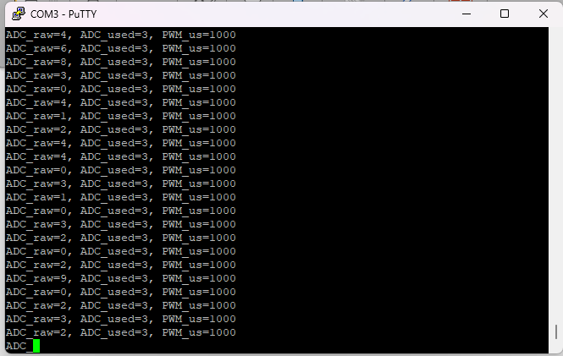

System Architecture:
Potentiometer -> ADC -> MCU logic -> PWM -> Servo
↓
UART telemetry -> PC
I should be able to explain:
- Why ADC exists
- Why PWM is used for servos
- What UART and deadband is.
- Why telemetry is separate from control

Phase 3 – Closed-Loop User Control
Date: Dec 27, 2025 – Dec 30, 2025
Goal: An external analog input is sampled in real time and directly controls a physical actuator through deterministic embedded logic.
Move joystick → voltage changes → ADC reads voltage → duty cycle changes → Servo motor rotates
Hardware:
- STM32 Nucleo board
- 2-axis Joystick Potentiometer
- SG90 9g Micro Servo
- Power Supply Module
What I Did: I implemented a real-time closed-loop user control system using an STM32 Nucleo board, a 2-axis joystick potentiometer, and a servo motor.
The STM32 provides a stable 3.3 V reference, which is applied to the joystick potentiometer configured as a voltage divider. As the joystick is moved, the potentiometer produces a variable analog voltage between 0 and 3.3 V at the ADC input pin.
The STM32’s 12-bit ADC samples this voltage, converting it from a continuous analog signal into a discrete digital value in the range 0-4095, providing approximately 0.8 mV resolution per step.
This digital value is then linearly mapped to a servo control command by converting ADC counts into a PWM pulse width between 1000 µs and 2000 µs, corresponding to the servo’s rotational limits.
A hardware timer (TIM3) generates a 50 Hz PWM signal, and the pulse width is updated continuously in the main control loop. Changing the joystick position directly affects the PWM pulse width, causing the servo to rotate proportionally and hold its position when the input is unchanged.
This system demonstrates:
- Analog signal acquisition
- Discrete-time signal processing
- Hardware-timed PWM actuation
- Human-in-the-loop closed-loop control

What I learned:
- A system is closed-loop if the output depends on the input continuously, not just once.
- The voltage amplitude at the LED pin is always ~3.3 V. The potentiometer does not lower the voltage level, it lowers the average power.
- Telemetry is an important embedded system feature. It is essentially a system monitoring feature. It analyzes the system state and collects data and reports is back to another system or user in a meaningful way. It is considered a non-negotiable feature of real-world embedded systems. In this personal project, I use telemetry to monitor ADC conversion .

